Kafka

Input

D:\installtools\kafka\kafka_2.11-0.11.0.1\bin\windows>kafka-console-producer.bat --broker-list localhost:9092 --topic test

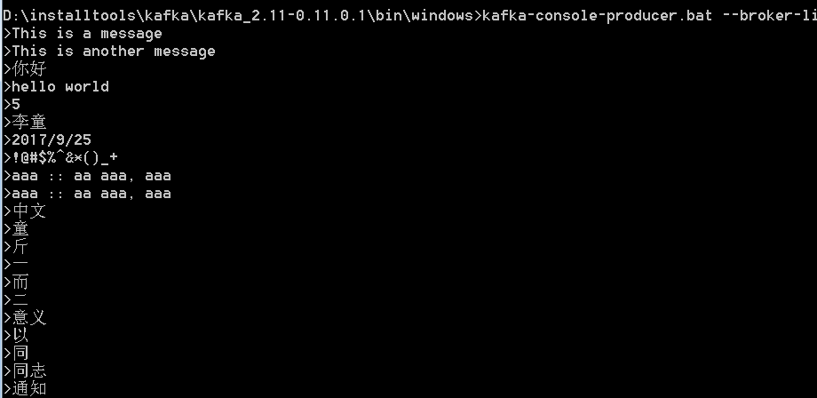

Output

D:\installtools\kafka\kafka_2.11-0.11.0.1\bin\windows>kafka-console-consumer.bat --bootstrap-server localhost:9092 --topic test --from-beginning

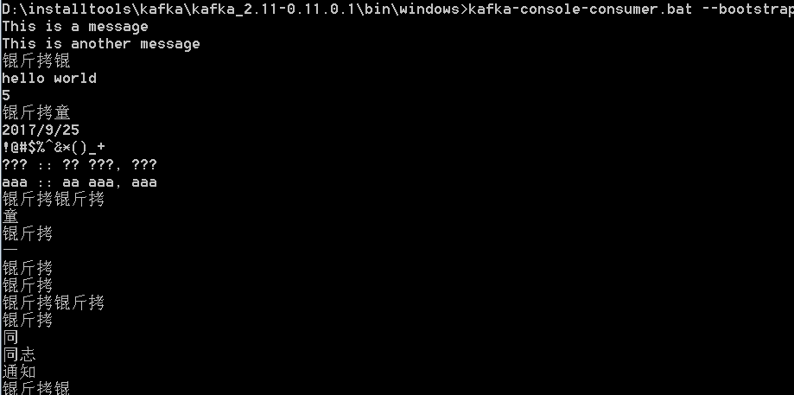D:\installtools\kafka\kafka_2.11-0.11.0.1\bin\windows>CHCP

活动代码页: 936

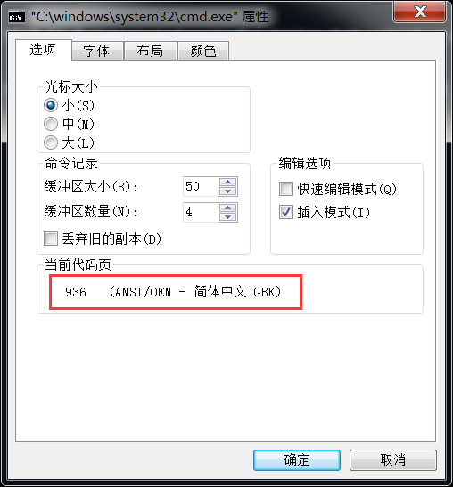

CHCP 65001

Input

D:\installtools\kafka\kafka_2.11-0.11.0.1\bin\windows>kafka-console-producer.bat --broker-list localhost:9092 --topic test

